**PROJECT-1**

**THREE-tier architecture**

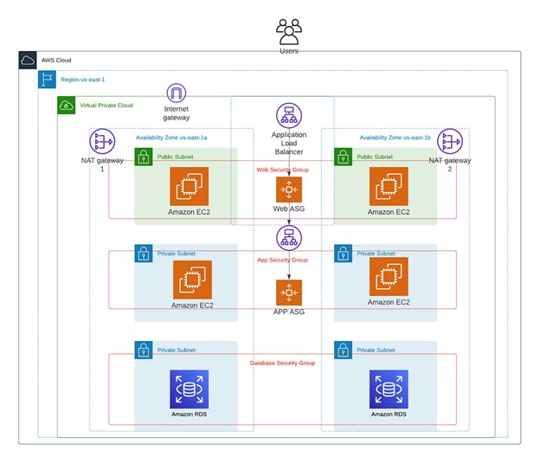

The 3-tier architecture is a commonly used architectural approach in Database Management Systems (DBMSs) for the design and development of applications that work with databases. The 3-tier architecture divides an application’s components into three tiers or layers. Each layer has its own set of responsibilities.

First we have to create VPC with the name of “three-tire”.

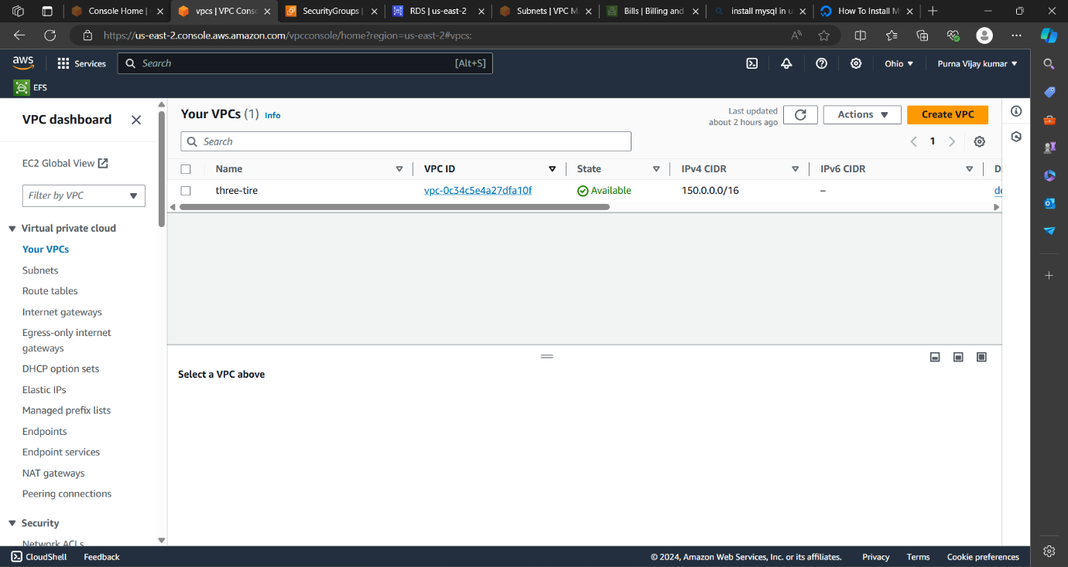

Create subnets which are two public and four are private subnets

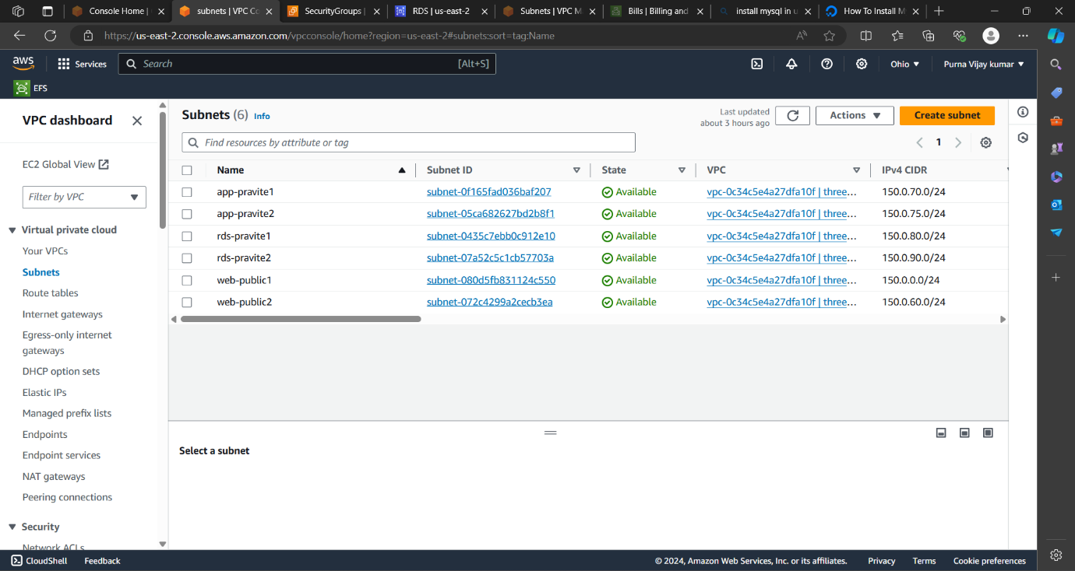

Create route two route tables one is for public and another one is pravite.

In public route table associate public subnets. And associate internetgateway.

In pravite route table associate private 4 subnets.And associate Nat gate way.

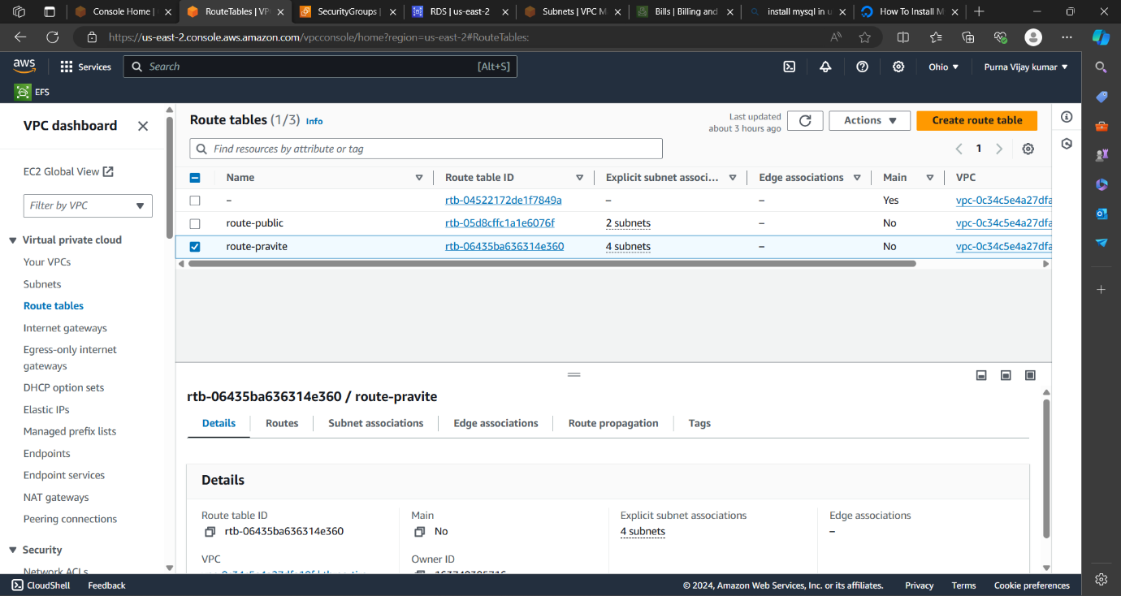

Create internet gate way attach it to vpc

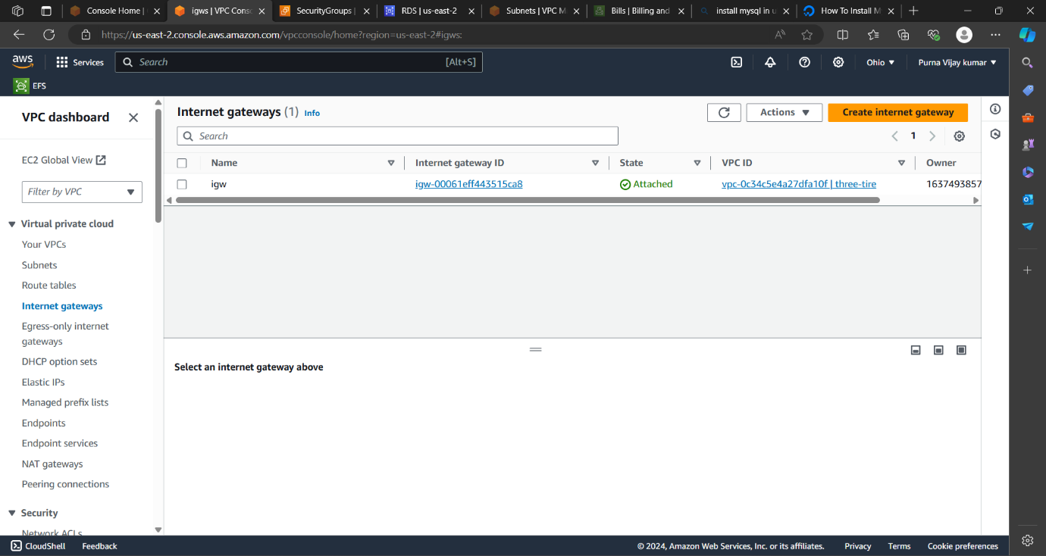

Create NAT gate way.

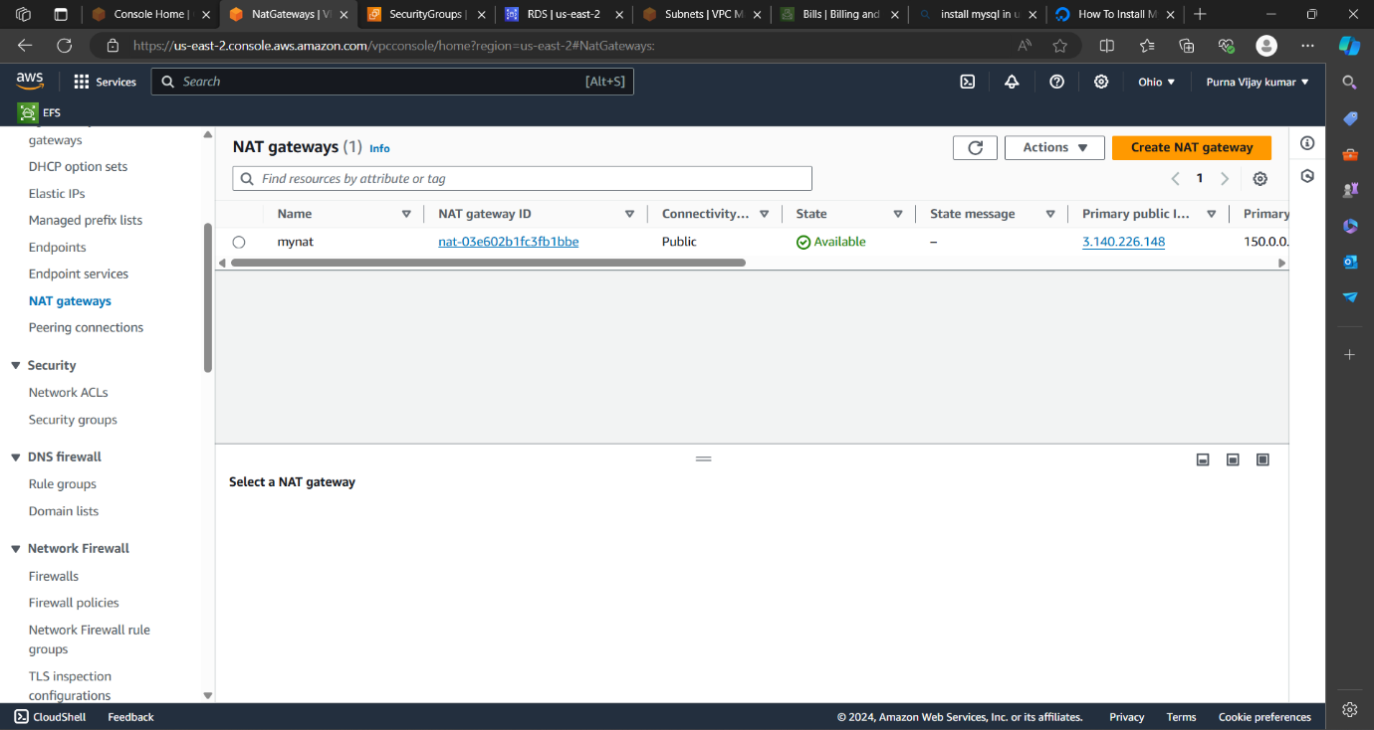

Create two load balancers for web and app . create target groups for the load balancers.

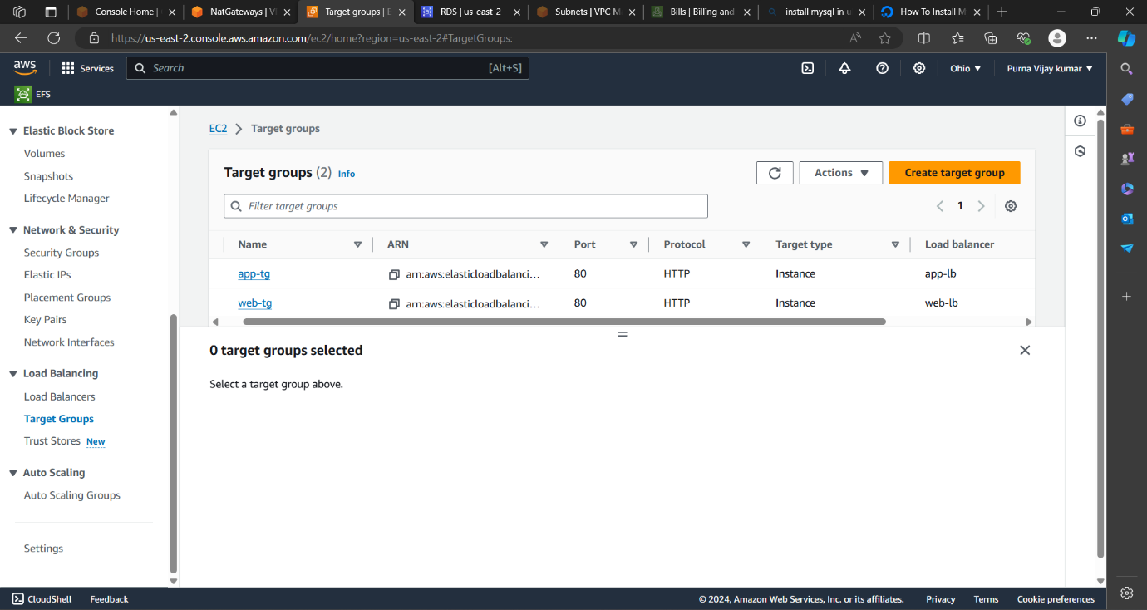

Create load balancer with the target groups both web and app.

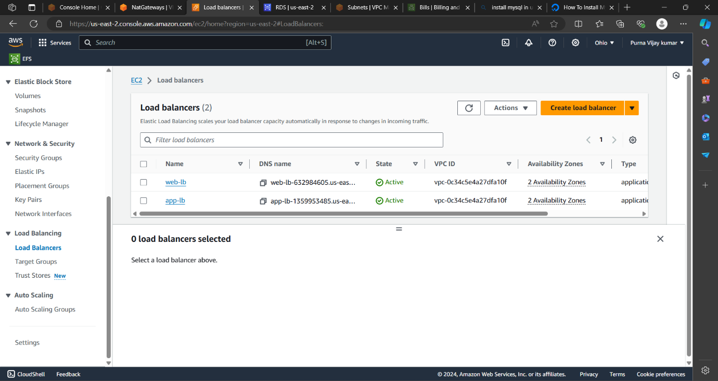

Create two ami’s for the launch templates. And create two launch templates for auto scaling.

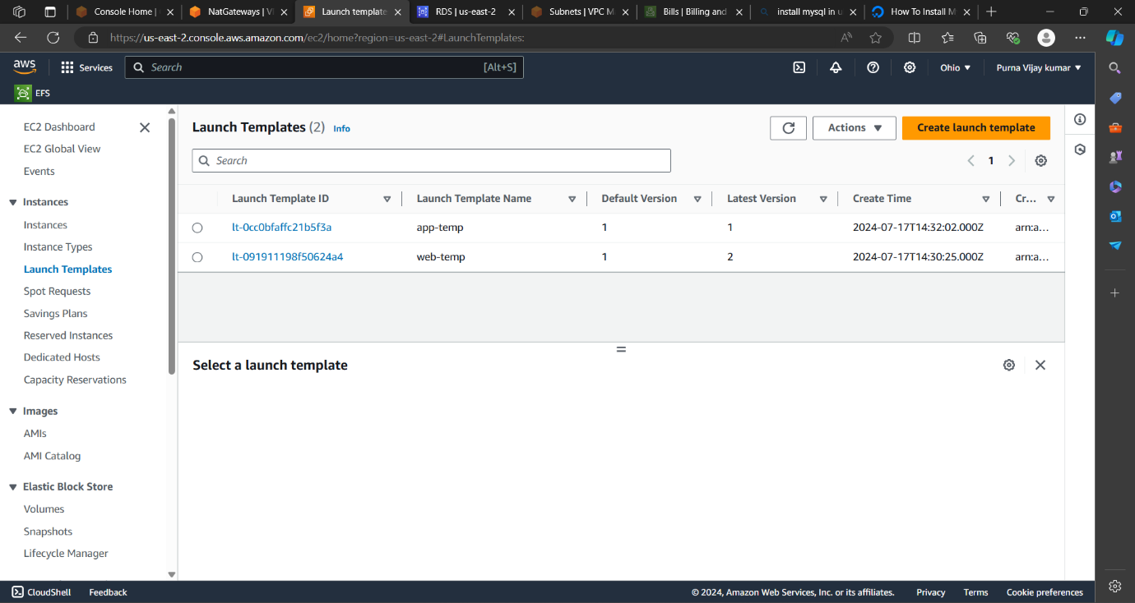

And create two for auto scaling.

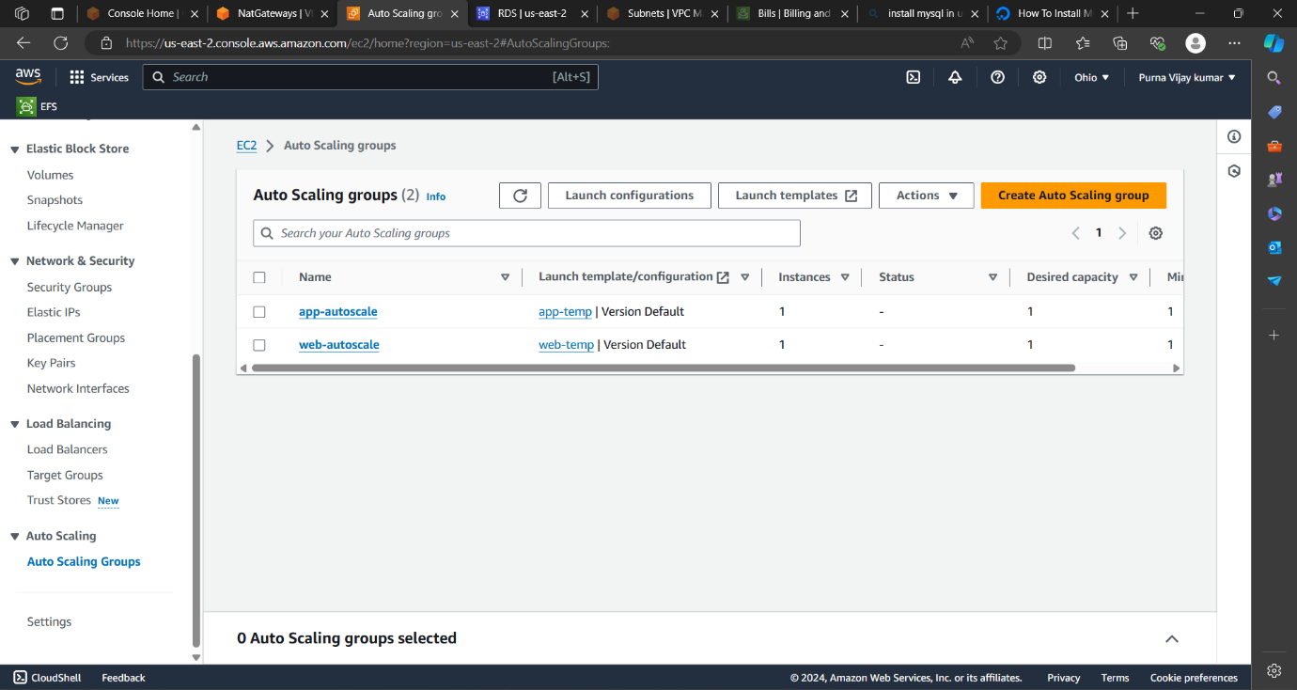

Create security groups for vpc ,web and app.

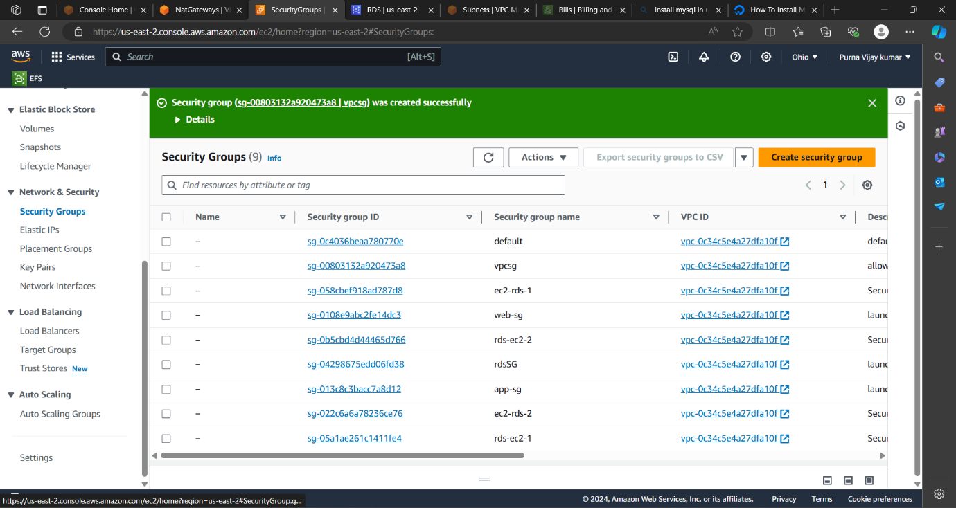

Create two RDS is datebase1 and database2 wich is avaliablity zone1 and availability zone 2.

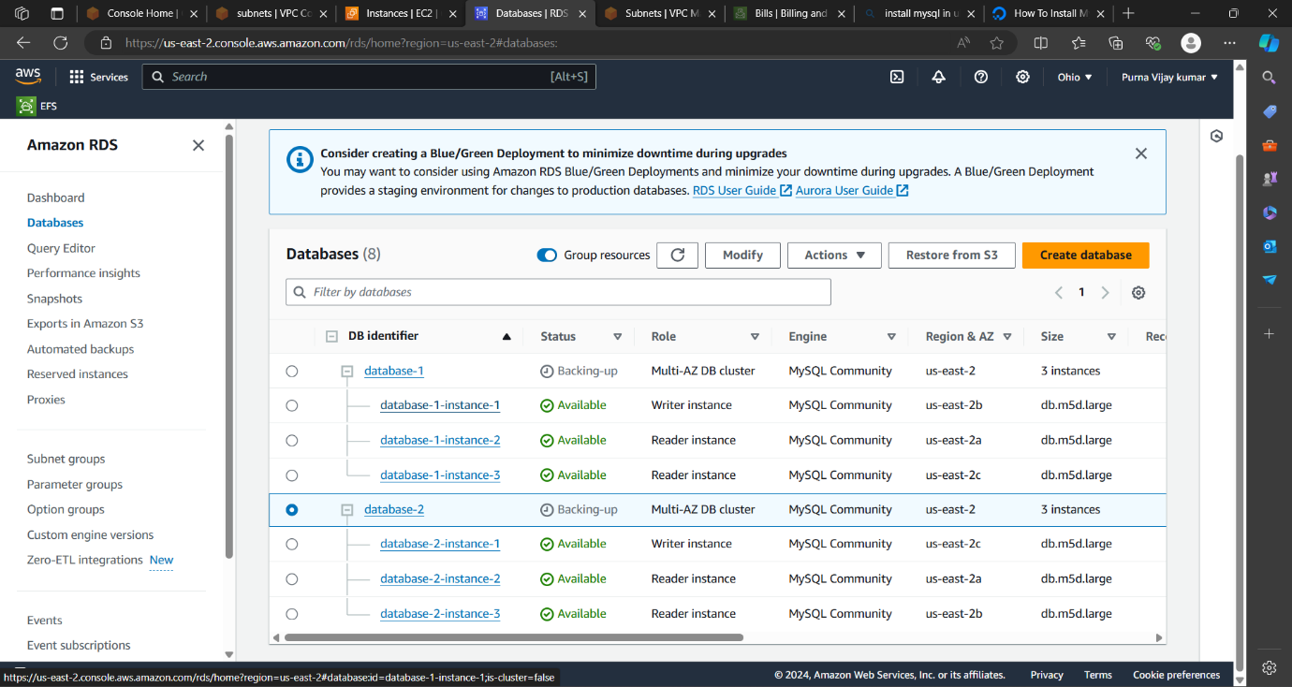

launch instance for web ,app and rds instance.

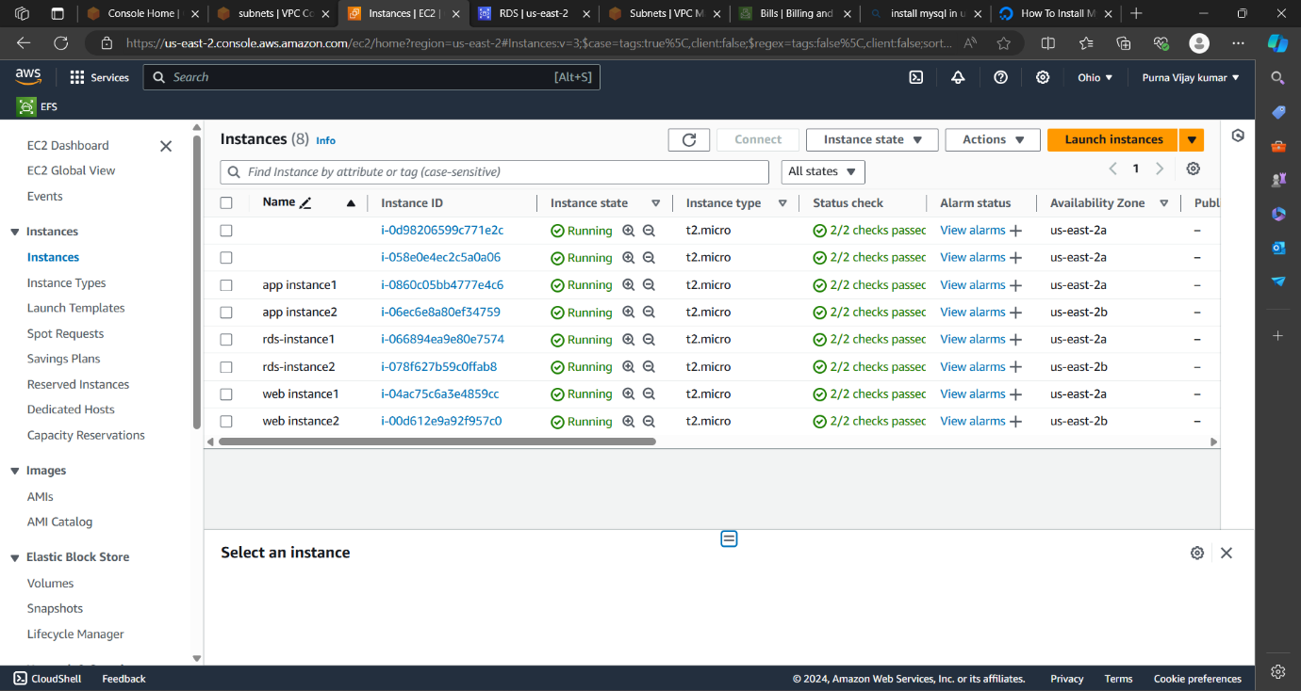

After all that connected to web instance1 and ping to pravite app instances and install mysql for the database as see in the below figure in the one avalibality zone.

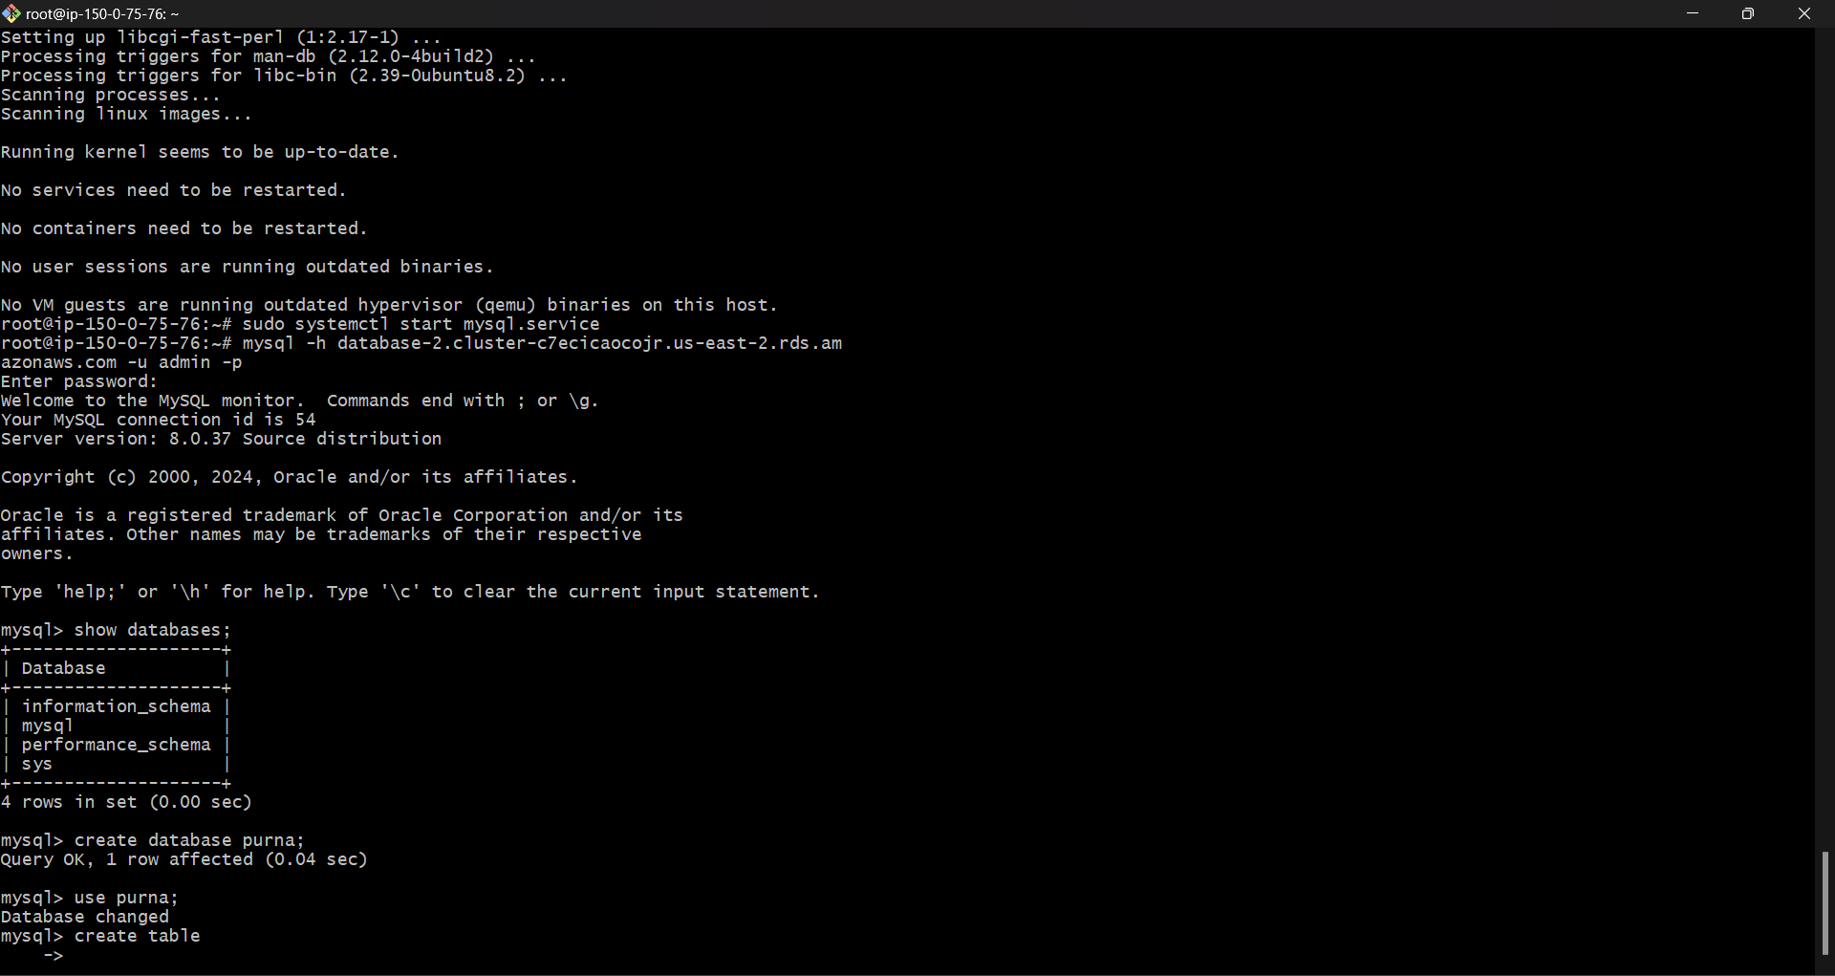

This is another zone that we connect to public instance and ping it to pravite instance and connect to RDS as shown in the below figure.

